How to Change Site Name

Author: Daniel
Reviewer：Eason
Account
Issue introduction
Change the name of site.
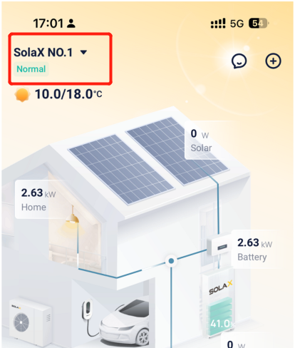
Operation guidance
Step1: Go to <Plant management> and find the site you want to change the name of.
Setting path：Me→Plant management→Plant
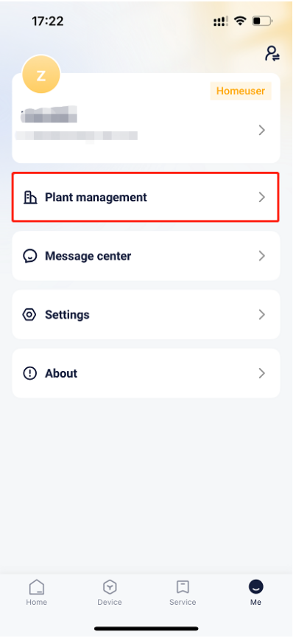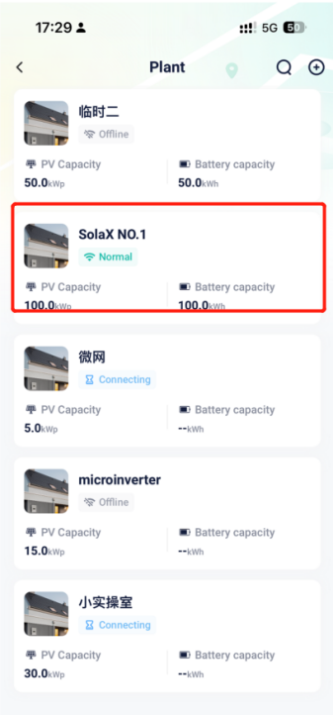
Step2：Go to <Edit plant> and change the name, then save the settings.
Setting path：<···>→Edit plant→Plant name→Save
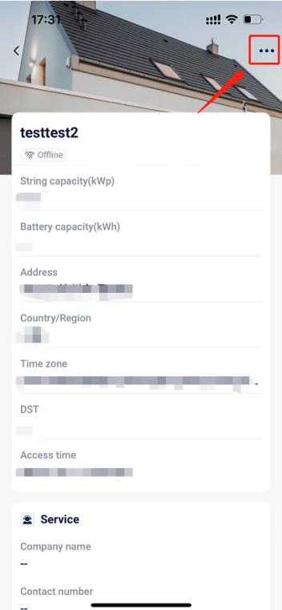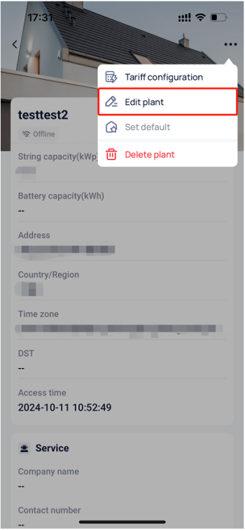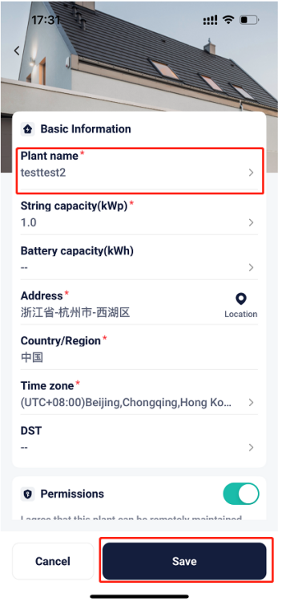
Please note
- Some special characters may prevent successful saving
- If the settings save fails, please check your mobile network, ensure a stable connection, log out of your account, and then log back in. Follow the steps above to make the changes.

